Project Design Phase-II

Data Flow Diagram & User Stories

Date | 8 March 2026
Team ID | 699d5fd13074df695bbbb146
Project Name | AI-Powered Customer Support & Service Automation
Maximum Marks | 4 Marks

1. Data Flow Diagram (DFD)
A Data Flow Diagram (DFD) represents how information flows through the AI-Powered Customer Support system. It illustrates how customer requests enter the system, how the support system processes them, and how the responses are generated.
The system involves the following key entities:
- Customer
- Support Agent
- Salesforce System
- AI Agentforce Service
- Database (Cases, Orders, Customers)
Explanation
- Customer submits a support request.
- The system processes the request and creates a case record.
- AI assistance generates suggested responses.
- Support agents review and resolve the issue.
- Customer receives updates and final resolution.

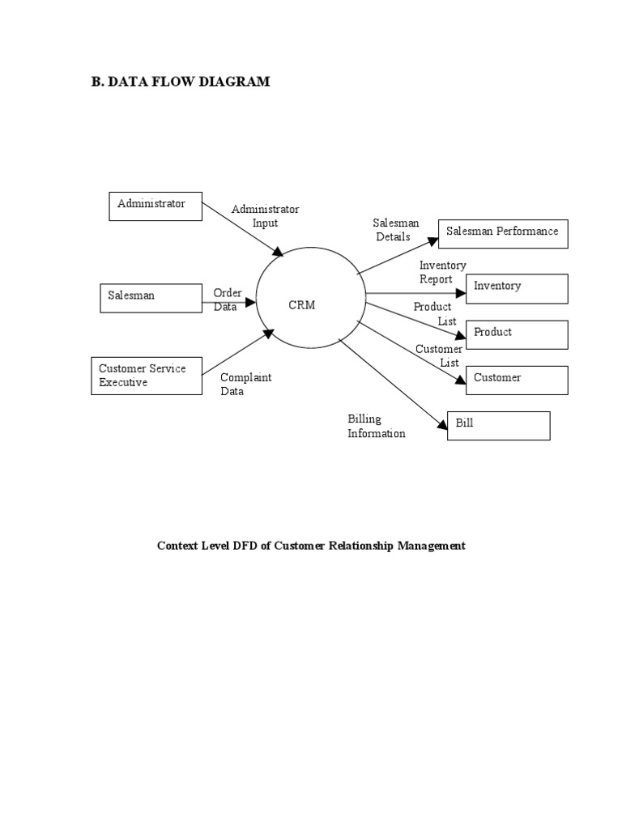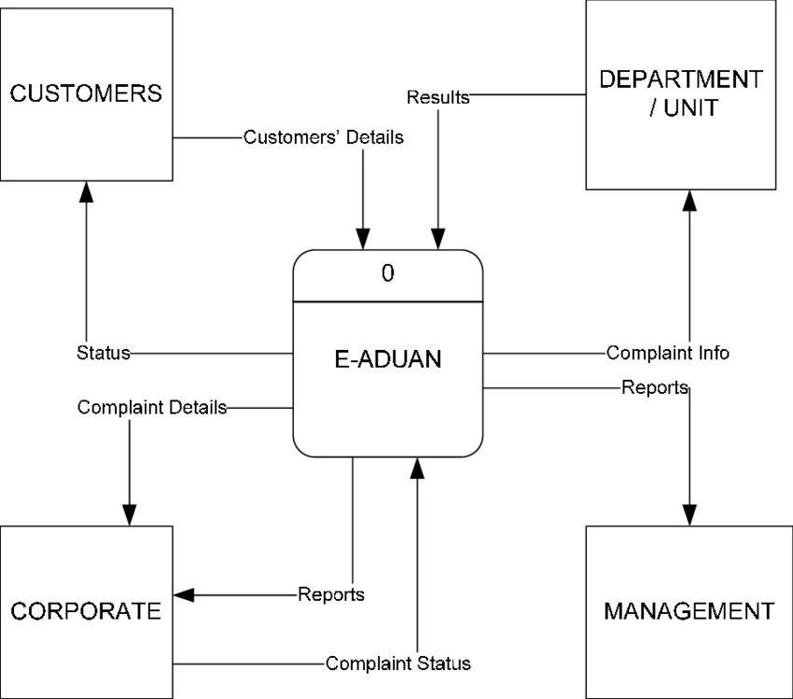

Process Description

Process 1: Case Creation

Customer submits issue through portal.

Process 2: Case Assignment

System automatically assigns case to appropriate support queue.

Process 3: AI Assistance

Agentforce AI generates recommended solutions.

Process 4: Case Resolution

Support agent reviews case and resolves issue.

Process 5: Feedback Collection

Customer receives resolution confirmation and provides feedback.

Data Stores

Customer Database

Product Database

Case Management Database

Order Database

User Stories
User stories describe system functionality from the perspective of different users such as customers, support agents, and administrators.

User Type | Functional Requirement (Epic) | User Story Number | User Story | Acceptance Criteria | Priority | Release
Customer | Case Creation | US-1 | As a customer, I can create a support case for my issue. | Case ID generated successfully | High | Sprint-1
Customer | Order Tracking | US-2 | As a customer, I can track my order status. | Order details visible | High | Sprint-1
Support Agent | Case Management | US-3 | As a support agent, I can view and update customer cases. | Case updated successfully | High | Sprint-2
Support Agent | AI Assistance | US-4 | As a support agent, I can receive AI-generated case summaries. | AI summary displayed | High | Sprint-3
Administrator | System Management | US-5 | As an admin, I can configure queues and automation flows. | Queue created successfully | Medium | Sprint-3
Administrator | Reporting | US-6 | As an admin, I can view reports and dashboards. | Reports generated successfully | Medium | Sprint-4

